Enforcing Mandatory Fields Using UI Policies and Migrating Changes with Update Sets

Introduction
In ServiceNow, maintaining accurate data is vital for effective service management. UI Policies help enforce mandatory fields by controlling form behavior without scripting, ensuring users provide required information. These changes, once created in a development instance, are moved to other environments using Update Sets, which track and migrate configurations safely and consistently.

Process

Steps to Create Update Set

- Open service now.
- Click on All >> search for Update Sets
- Select Local Update Sets
- Click on new
- Fill the details below and make current.
- Click submit.
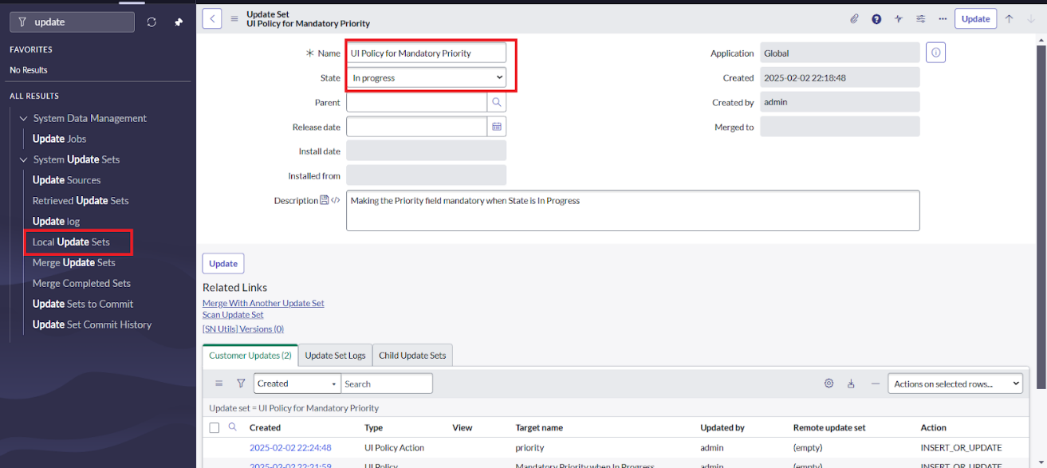

Steps to Create UI policy
- Open service now.
- Click on All >> search for UI policies
- Navigate to System UI >> UI Policies
- Click on new
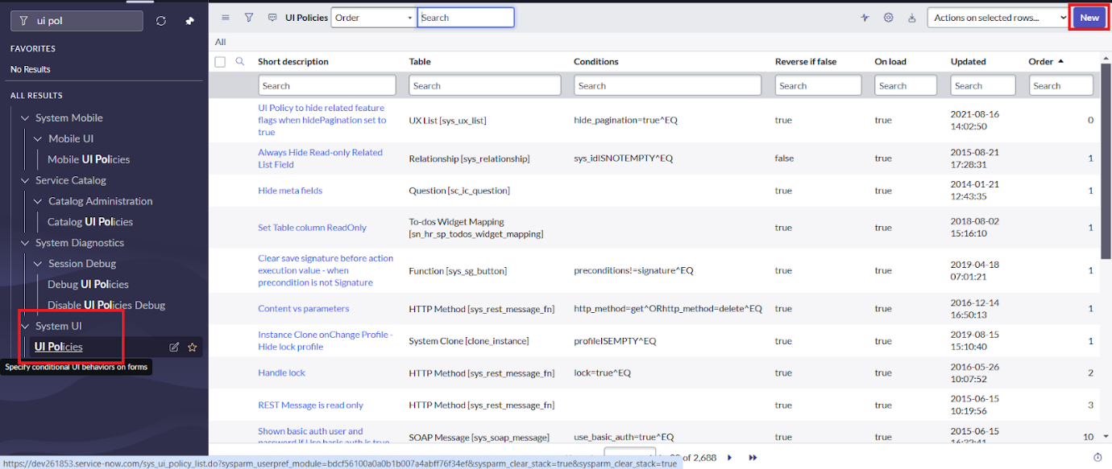

- Fill the following details and Save
- Scroll Down and add ‘priority’ Field on Ui policy Actions
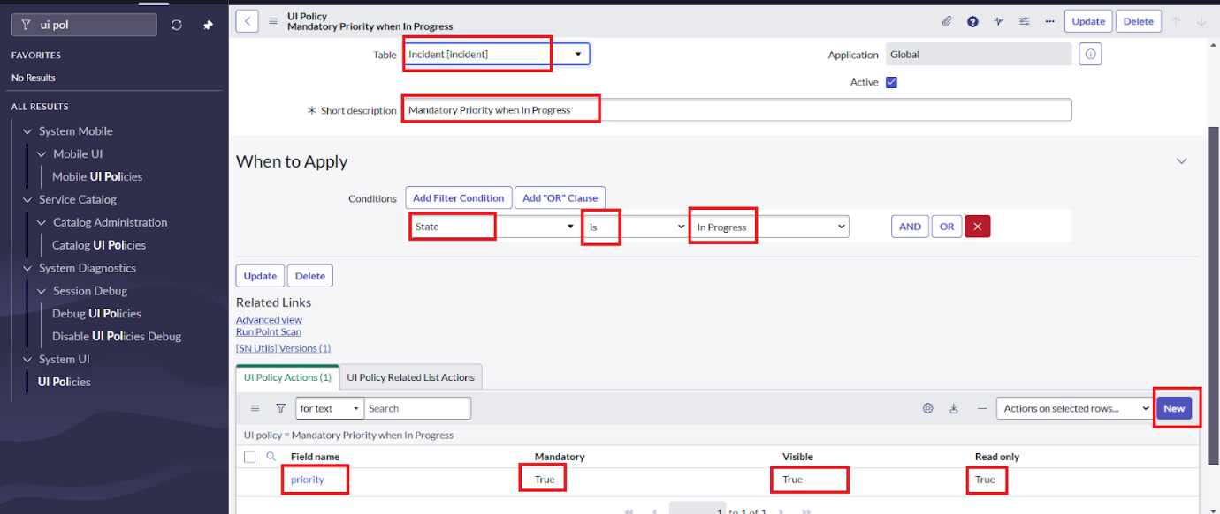
- Click on submit.

Steps to Check Update Set

- Navigate to the System Update Sets > Local Update Sets.
- open the ‘UI policy for mandatory priority’ Update Set.
- Verify that your UI Policy and UI Policy Action are listed.
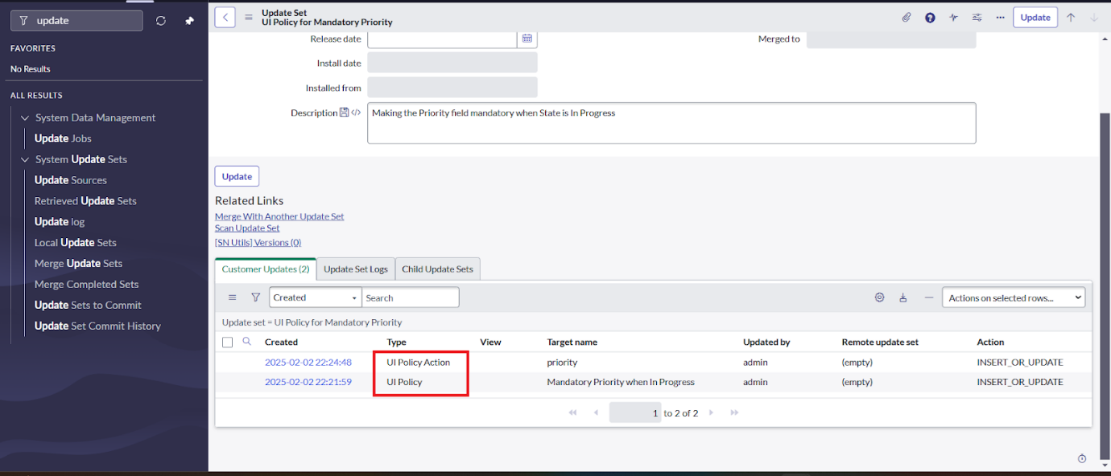

Steps to Export and Import the Update Set

- Set State to Complete and Click Export to XML on the Update Set record.
- Download the XML file.
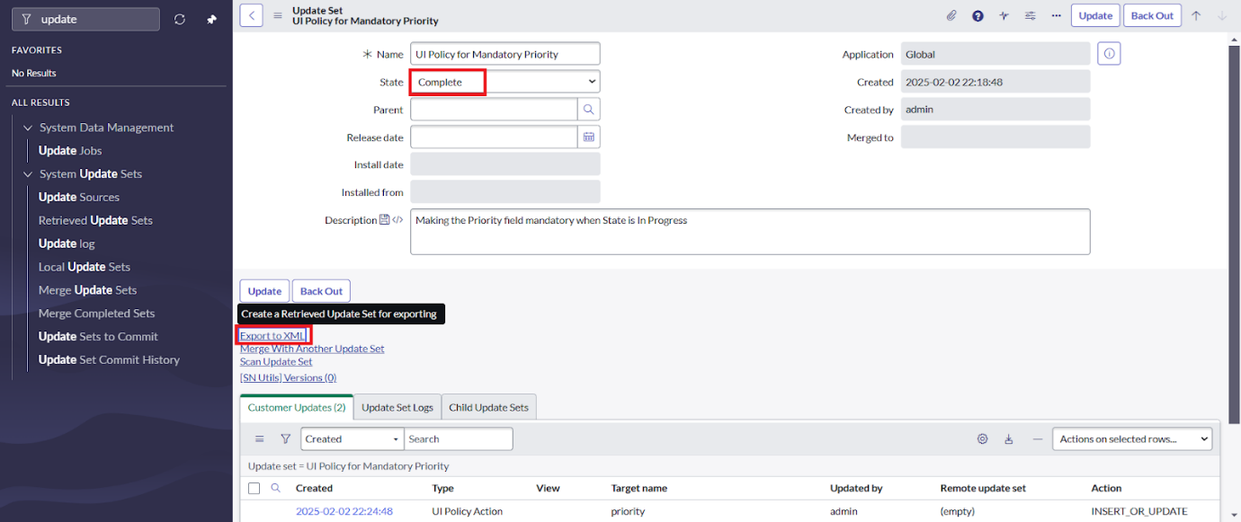
- Now Open Another Instance to Export Update Set.
- Go to System Update Sets >> Retrieved Update Sets.
- Click on the Import update set from XML and Select File and Upload
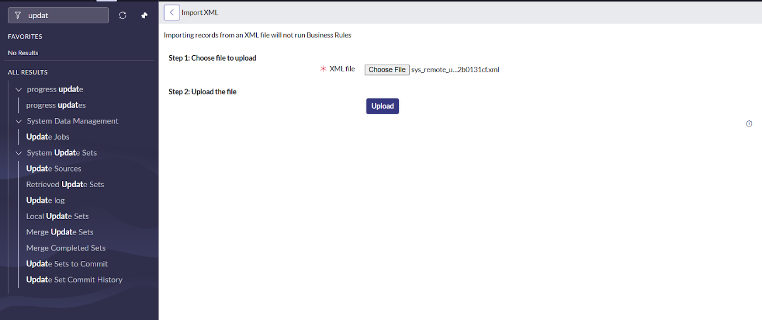
- Open the update set that you have created in your instance here.
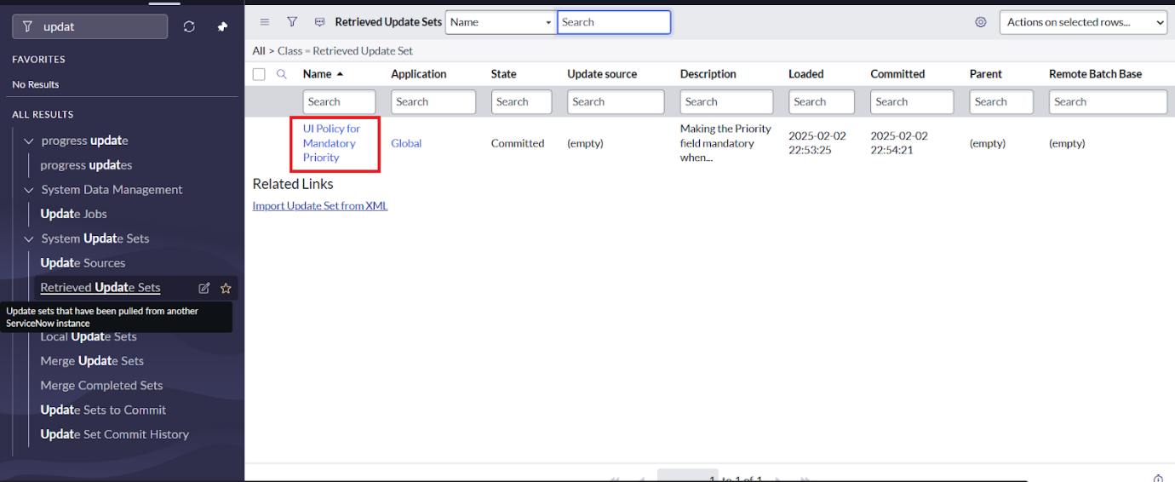
- Preview the Update Set.
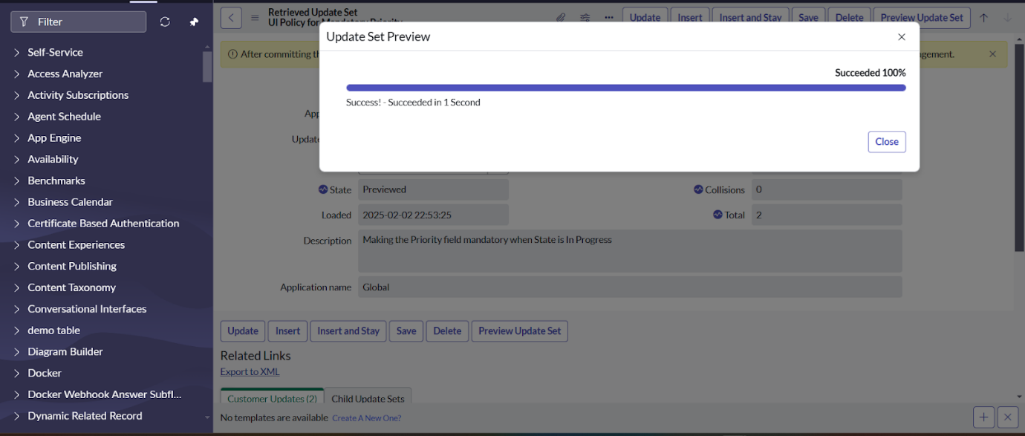
- Commit the Update Set.
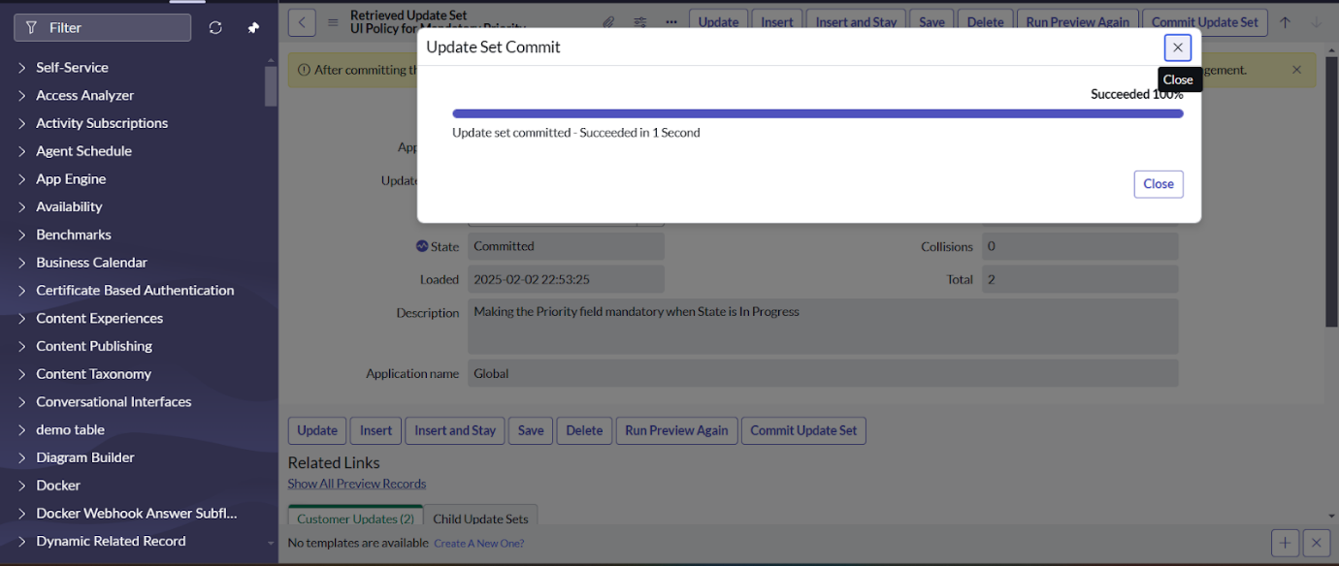

Steps to Testing Incident

- Go to the incident module.
- Open an existing incident or create a new one.
- Change the State is In-progress
- The Priority field should now be mandatory
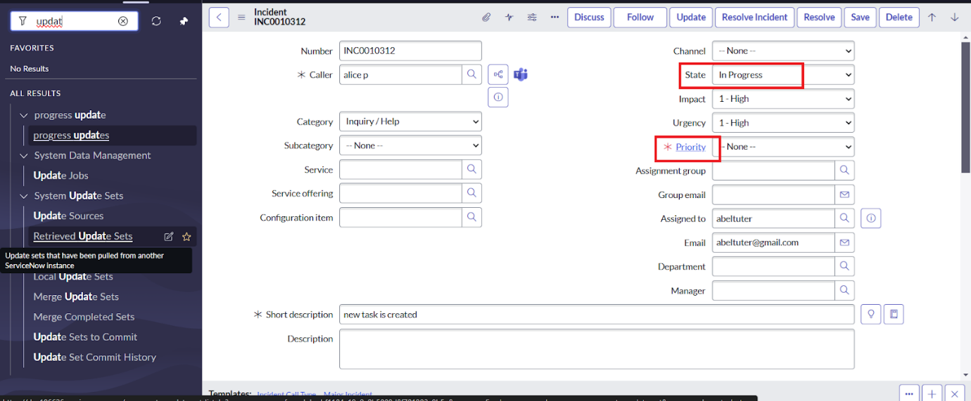

Conclusion
Using UI Policies to enforce mandatory fields improves data quality and user guidance. Update Sets ensure these configurations are reliably transferred across instances. Together, they support consistent validations, smooth deployments, and better governance in ServiceNow.

